NEWS PHOTO
Barcelona, July x, 2017
Concessions
Areas lands in the Fuerteventura Airport with Burger King
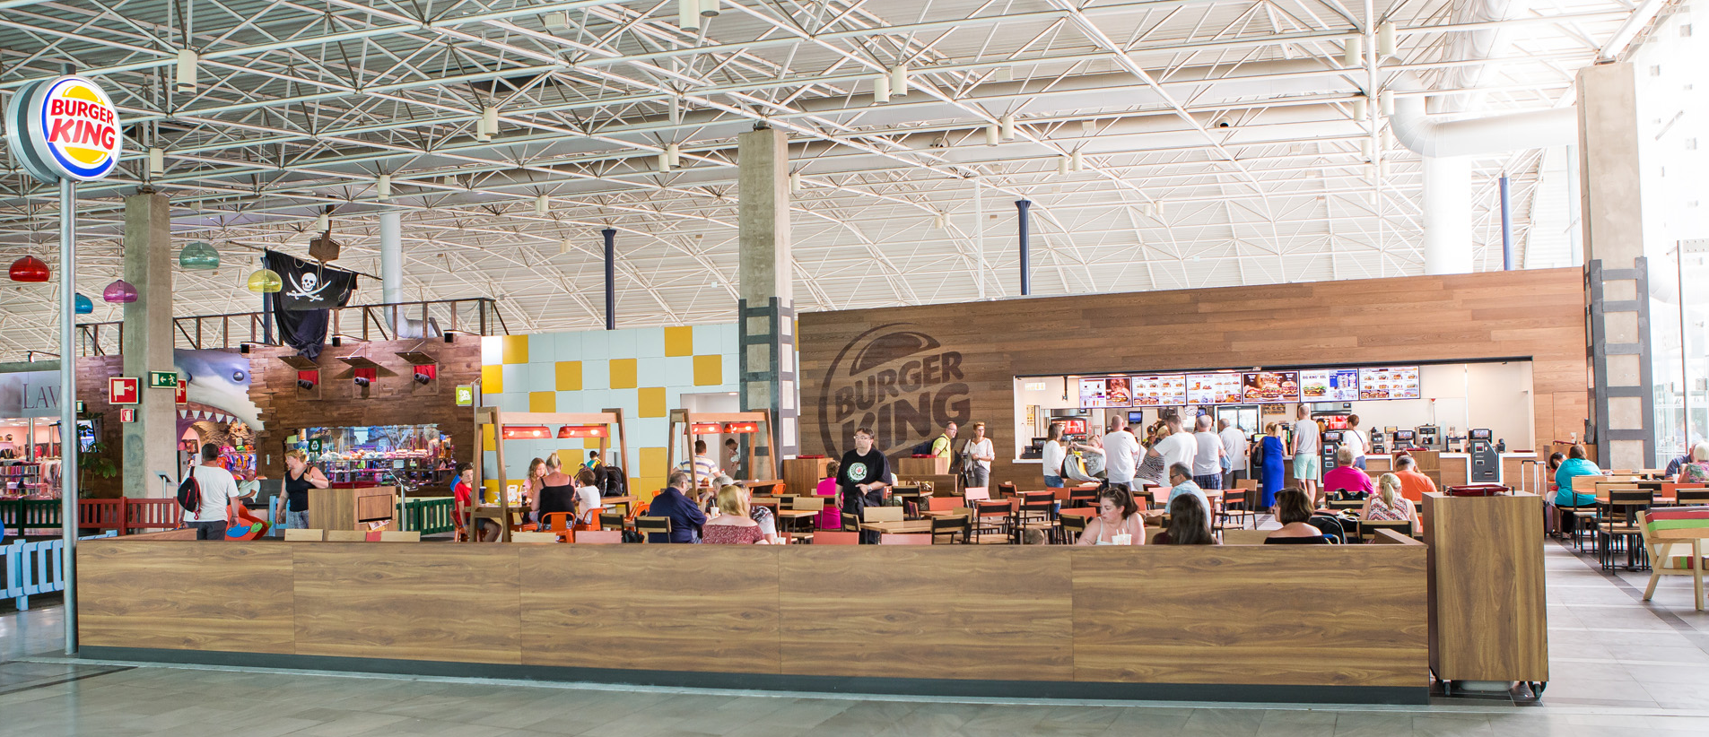

Today, Areas, the leading Food&Beverage and Travel Retail company, unveils a 9407-square foot outlet which will include a Burger King. Areas will manage this outlet, located in the boarding hall of the terminal's first floor, which also includes a terrace. The new contract is valid for 8 years and will provide employment for 45 workers.

Areas' detailed understanding of the airport business, together with studies that allow passengers profiles to be analyzed in depth, ensure that the company can choose the brands best suited to each type of client. In the case of the Fuerteventura's Airport, this brand perfectly matches the passenger's typical profile: a 44 year old passenger, generally foreign (82%), traveling as a couple and who has virtually no seasonal variation.

Burger King is one of the world's favorite burger brands, present in more than 100 countries with more than 15,000 restaurants. In Spain, Areas operates 14 outlets including this one, as precisely this week the company has also opened another Burger King outlet in T1 of the Adolfo Suárez Madrid-Barajas Airport.

About Areas

Areas is one of the world's leaders in Food & Beverage and Travel Retail with €1.668 billion of revenues in 2016. As a global brand of the Elior Group, Areas welcomes 330 million customers to its 2,000 outlets in 13 countries across Europe, the US, Mexico, and Chile every year.
As a benchmark food and beverage operator in the world of travel, focused on quality for more than 45 years, Areas operates at large and small communication hubs around the world (airports, train stations, highway travel plazas), as well as key points at exhibition venues and leisure centers.
Concerning its culture of operational excellence, Areas has in-depth know-how of travelers' needs and the most extensive array of food and beverage concepts on the market, allowing it to always offer a perfect combination adapted to the 900,000 customers it receives on a daily basis.

For more information: http://www.areas.com Areas on Twitter @Areas_ES Instagram areas.es

About Elior Group

Founded in 1991, the Elior Group, one of the world's leaders in food and beverage and services, has today become the benchmark in the business, teaching, health, and tourism environment.

The Group posted turnover of €5.896 billion in 2015-2016. Our 120,000 employees attend 4.4 million customers every day across 23,000 restaurants and outlets in 15 countries. The company's mission consists of attending and caring for each one of them with food and beverage solutions and personalized services for an innovative customer experience.

Elior, which is particularly attentive to its responsibility as a business, has been a signatory of the United Nations Global Pact since 2004 and attained the Advanced Level distinction in 2015. The professionalism demanded of its teams and its daily commitment to quality, innovation, and the best possible service can be clearly seen in its motto "Time Savored".

For more information visit the website (http://www.eliorgroup.com) or follow us on Twitter (http://twitter.com/Elior_Group)

Press contacts:
Victor Palacio – v.palacio@romanyasociados.es
María Martinez – maria.martinez@romanyasociados.es
934 142 340.
677 782 370.

