Photo news
Barcelona, October 18, 2018
Grand Opening
COMO touches down in airports as a new outlet in the Barcelona-El Prat airport

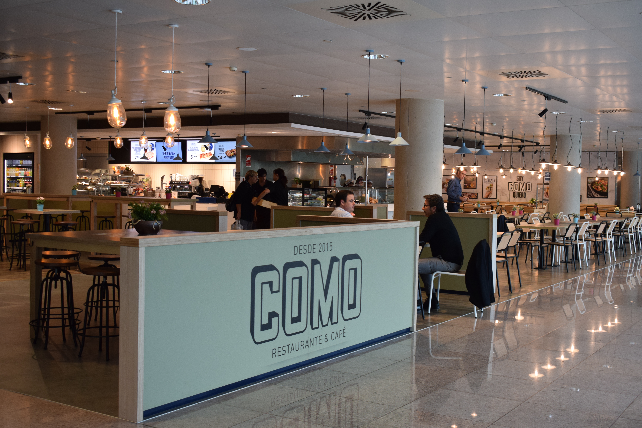

Areas, a leading Food&Beverage and Travel Retail company, reinforces its own brand COMO with the grand opening of the brand's fourth outlet in the Barcelona-El Prat airport. The brand, already present in Sants train station and in the La Selva and La Jonquera travel plazas, thus takes the leap to the airport market. Located in Terminal 1, the new outlet features a surface area of 409 m² and capacity for 140 diners.

COMO is an innovative restaurant–cafeteria–grab&go concept designed to cover the needs for all types of travelers and all times of the day. With a carefully decorated, modern design, this own brand by Areas offers an extensive array of trendy, fresh, natural and regional products, made on the spot for the passengers in El Prat.

The new COMO outlet is Areas' sixth grand opening as part of the latest food&beverage tender launched by Aena, in which Areas was awarded the operations of 15 new outlets in Barcelona's airport. Already present in the airport with 14 restaurants and shops, Areas became the largest commercial operator in El Prat after the tender was decided, with a total of 29 food&beverage and retail outlets.

About Areas

Areas is one of the global leaders in the travel catering and retail industry, generating €1.774 billion in revenue in 2016/2017. A global brand of Elior Group, Areas welcomes 330 million customers each year in 2,000 restaurants and points of sale in 14 countries, throughout Europe as well as in the USA, Mexico, Chile and Colombia.

As the caterer of choice in the travel and leisure markets, focusing on quality for 50 years, Areas is present in transportation hubs large and small across the world (airports, train stations, motorway service plazas), as well as in exhibition centers and leisure parks. Building upon a culture of operational excellence, Areas draws on its in-depth understanding of travelers’ needs and the most extensive range of catering concepts on the market to offer the perfect blend of ingredients for each of its 900,000 daily customers to savor.

For further information: http://www.areas.com Areas in Twitter @Areas / @Areas_FR / @Areas_ES Instagram: @areas.es
Media contacts:
Victor Palacio – v.palacio@romanyasociados.es
María Martinez – maria.martinez@romanyasociados.es
934 142 340
677 782 370

