Barcelona, 05 October 2018
Grand Opening
Areas opens the largest Burger King in Spain in the Barcelona-El Prat airport

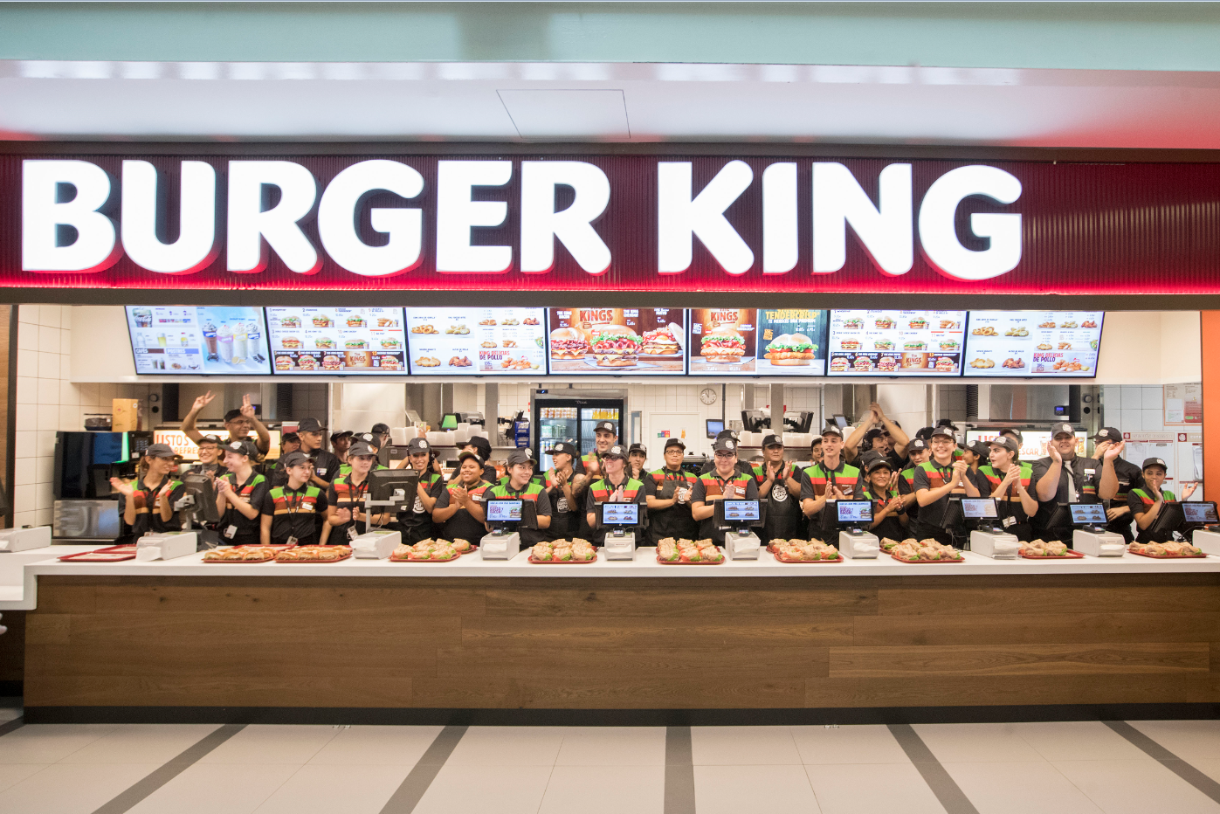

Areas, a leading Food&Beverage and Travel Retail company, strengthened its relationship with Burger King with the opening of its twentieth outlet of this popular brand. Located in the Sky Center shopping area in Terminal 1 of the Barcelona-El Prat airport, this new outlet is the largest Burger King in Spain with a surface area of 661 m², 85 employees, two kitchens and capacity for 223 diners.

The new Burger King in Barcelona-El Prat airport, which forms part of the latest food&beverage tender launched by Aena in this airport, will have 12 self-service kiosks plus 7 payment points at the counter to make it easier for passengers in transit.

This new opening reinforces the partnership between Burger King and Areas, a leading operator in food and beverage in the travel world which manages 20 outlets of the Burger King brand in major concessions spaces in Spain and Portugal. The 4 Burger King restaurants already operating in the Barcelona-El Prat airport will soon have 1 more in the upcoming months in Terminal 2.

Acerca de Areas

Areas is one of the global leaders in the travel catering and retail industry, generating €1.774 billion in revenue in 2016/2017. A global brand of Elior Group, Areas welcomes 330 million customers each year in 2,000 restaurants and points of sale in 14 countries, throughout Europe as well as in the USA, Mexico, Chile and Colombia.

As the caterer of choice in the travel and leisure markets, focusing on quality for 50 years, Areas is present in transportation hubs large and small across the world (airports, train stations, motorway service plazas), as well as in exhibition centers and leisure parks. Building upon a culture of operational excellence, Areas draws on its in-depth understanding of travelers’ needs and the most extensive range of catering concepts on the market to offer the perfect blend of ingredients for each of its 900,000 daily customers to savor.

For further information: http://www.areas.com Areas in Twitter @Areas / @Areas_FR / @Areas_ES Instagram: @areas.es
Media contacts:
Victor Palacio – v.palacio@romanyasociados.es
María Martinez – maria.martinez@romanyasociados.es
934 142 340
677 782 370

